**//nói sơ lược 1 chút về fix bản quyền**

**Hiện có 3 cách: 1: là bạn tắt wifi xong dô app, rồi bật wifi lại (này tuỳ máy hên xui, nhưng ko đảm bảo) mình test trên máy 1 người xác định mac rồi, vẫn dính ngay sau khi xác định vài phút**

**2: dùng phần mềm chặn kết nối wifi đến app, này tuỳ máy hên xui, có người xài bền, có người xài là crash ngay**

**3:ĐỊNH TUYẾN IP: này bền và hiệu nghiệm nhất, này xài được cho rất nhiều ứng dụng, nhiều người xài nó cho IDM, cách này đại khái là bạn chặn địa chỉ IP máy chủ, Adobe chắc cũng có hàng trăm IP khác nhau, chỉ cần chặn cái IP check của nó thôi. Chặn thì hiện tôi không biết có phần mềm nào không, nhưng chắc chắn là nó không ổn định, vì phải duy trì hoạt động app. Nên là bạn chỉ có thể dùng routing, theo như kiến thức tôi học từ môn nhập môn mạng máy tính học kỳ hè vừa rồi, thì địa chỉ IP chúng ta có phương pháp routing tức là định tuyến (vạch ra tuyến đường) của 1 địa chỉ IP, routing thường dùng để bạn kết nối wifi, kết nối server, client,….. ở đây mình sẽ truy cập vào file host của máy, file này nó bị khóa trong thư mục private, mà nó cho edit được, trong Mac thì không cho nên cần dùng câu lệnh sudo nano chỉnh trực tiếp trong terminal, trong đó bạn chỉ cần nhập địa chỉ IP + địa chỉ web, địa chỉ IP mình sẽ nhập địa chỉ sai vào, như thế khi truy cập web nó sẽ trỏ đến địa chỉ sai đó thay vì địa chỉ mạng của bạn, như thế đồng nghĩa bạn và cả trang web đó đều sẽ không truy cập được nhau. Như thế thì server nó sẽ không kiểm tra được bản quyền của bạn.**

***#lưu ý là xoá app đi cài lại mới áp dụng được cách 3, 1 khi dính bản quyền r thì nó ăn sâu luôn rồi.***

**//MACOS**

**Mở Terminal: chạy:**

*sudo nano /private/etc/hosts*

**bấm nút mũi tên đi xuống trên bàn phím xuống dưới : xong paste các dòng phía dưới vào như này:**

**+ Lưu ý paste vô giữa cái Broadcasthost và dòng “::1 localhost”**

**Sau đó bấm control + X, rồi bấm y, rồi enter là xong.**

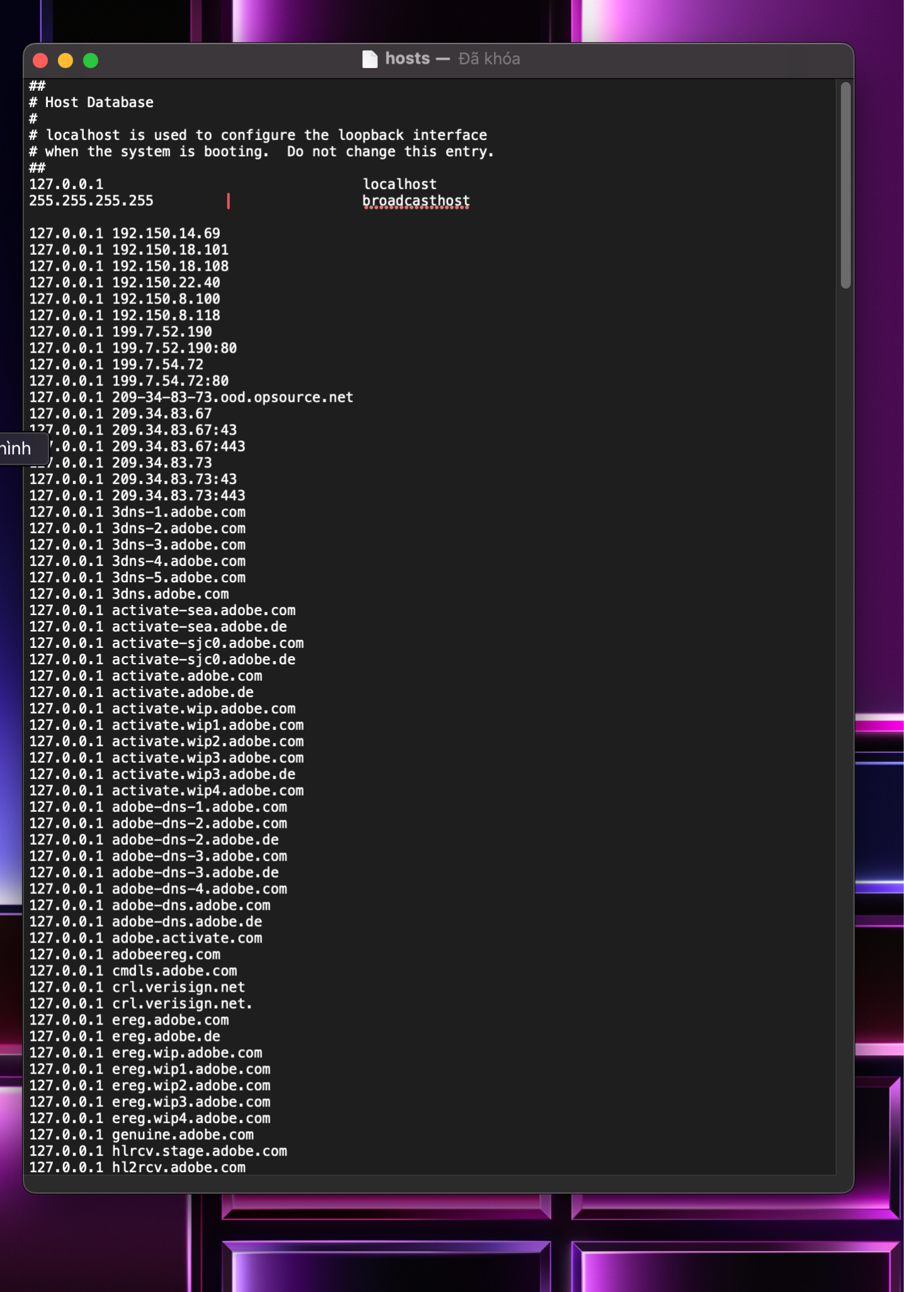

**//WIN**

1. **Open the Start menu, and** [**go to Windows Accessories**](https://winaero.com/blog/how-to-navigate-apps-by-alphabet-in-windows-10-start-menu/)**.**
2. **Right-click the Notepad app and select More - Run as Administrator.**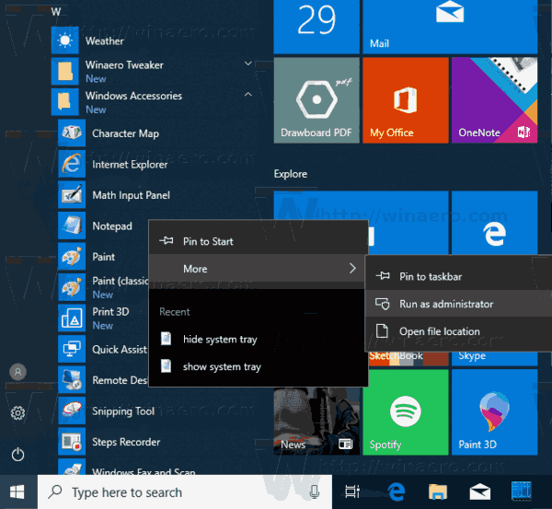
3. **In Notepad, click the File menu - Open, or press the Ctrl + O keys.**
4. **Navigate to the folder C:\Windows\System32\drivers\etc.**
5. **Select "All Files" from the drop-down menu.**
6. **Double-click the hosts file.**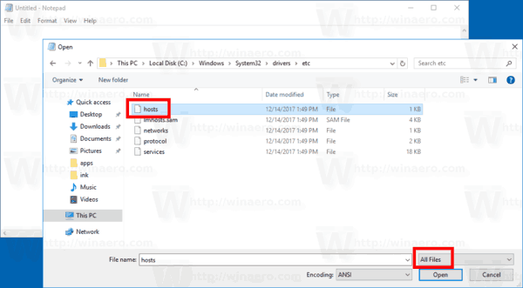
7. **On a new line in the hosts file opened in Notepad, type 127.0.0.1. This is your *localhost address* (the default local address of the PC).**
8. **Press Tab or add spaces after you localhost address, and type the web site address (e.g. *google.com* or *www.facebook.com*) you want to block.**
9. **Save the file(Ctrl + S).**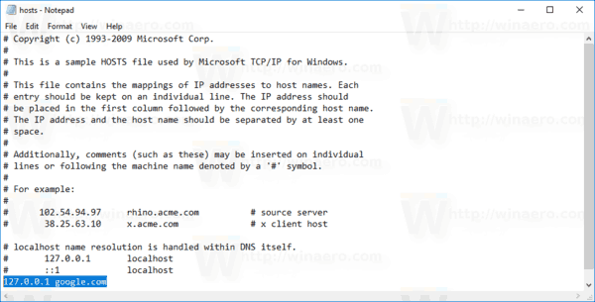

**IP BLOCK ADOBE**

**127.0.0.1 192.150.14.69  
 127.0.0.1 192.150.18.101  
 127.0.0.1 192.150.18.108  
 127.0.0.1 192.150.22.40  
 127.0.0.1 192.150.8.100  
 127.0.0.1 192.150.8.118  
 127.0.0.1 199.7.52.190  
 127.0.0.1 199.7.52.190:80  
 127.0.0.1 199.7.54.72  
 127.0.0.1 199.7.54.72:80  
 127.0.0.1 209-34-83-73.ood.opsource.net  
 127.0.0.1 209.34.83.67  
 127.0.0.1 209.34.83.67:43  
 127.0.0.1 209.34.83.67:443  
 127.0.0.1 209.34.83.73  
 127.0.0.1 209.34.83.73:43  
 127.0.0.1 209.34.83.73:443  
 127.0.0.1 3dns-1.adobe.com  
 127.0.0.1 3dns-2.adobe.com  
 127.0.0.1 3dns-3.adobe.com  
 127.0.0.1 3dns-4.adobe.com  
 127.0.0.1 3dns-5.adobe.com  
 127.0.0.1 3dns.adobe.com  
 127.0.0.1 activate-sea.adobe.com  
 127.0.0.1 activate-sea.adobe.de  
 127.0.0.1 activate-sjc0.adobe.com  
 127.0.0.1 activate-sjc0.adobe.de  
 127.0.0.1 activate.adobe.com  
 127.0.0.1 activate.adobe.de  
 127.0.0.1 activate.wip.adobe.com  
 127.0.0.1 activate.wip1.adobe.com  
 127.0.0.1 activate.wip2.adobe.com  
 127.0.0.1 activate.wip3.adobe.com  
 127.0.0.1 activate.wip3.adobe.de  
 127.0.0.1 activate.wip4.adobe.com  
 127.0.0.1 adobe-dns-1.adobe.com  
 127.0.0.1 adobe-dns-2.adobe.com  
 127.0.0.1 adobe-dns-2.adobe.de  
 127.0.0.1 adobe-dns-3.adobe.com  
 127.0.0.1 adobe-dns-3.adobe.de  
 127.0.0.1 adobe-dns-4.adobe.com  
 127.0.0.1 adobe-dns.adobe.com  
 127.0.0.1 adobe-dns.adobe.de  
 127.0.0.1   
 127.0.0.1 adobeereg.com  
 127.0.0.1 cmdls.adobe.com  
 127.0.0.1 crl.verisign.net  
 127.0.0.1 crl.verisign.net.** *127.0.0.1 ereg.adobe.com  
 127.0.0.1 ereg.adobe.de  
 127.0.0.1 ereg.wip.adobe.com  
 127.0.0.1 ereg.wip1.adobe.com  
 127.0.0.1 ereg.wip2.adobe.com  
 127.0.0.1 ereg.wip3.adobe.com  
 127.0.0.1 ereg.wip4.adobe.com  
 127.0.0.1 genuine.adobe.com  
 127.0.0.1 hlrcv.stage.adobe.com  
 127.0.0.1 hl2rcv.adobe.com  
 127.0.0.1 hl2rcv.adobe.de  
 127.0.0.1 ims-na1-prprod.adobelogin.com  
 127.0.0.1 lm.licenses.adobe.com  
 127.0.0.1 lmlicenses.wip4.adobe.com  
 127.0.0.1 na1r.services.adobe.com  
 127.0.0.1 na2m-pr.licenses.adobe.com  
 127.0.0.1 na2m-stg2.licenses.adobe.com  
 127.0.0.1 na4r.services.adobe.com  
 127.0.0.1 ocsp.spo1.verisign.com  
 127.0.0.1 ood.opsource.net  
 127.0.0.1 practivate.adobe  
 127.0.0.1 practivate.adobe.* **127.0.0.1 practivate.adobe.com  
 127.0.0.1 practivate.adobe.de  
 127.0.0.1 practivate.adobe.ipp  
 127.0.0.1 practivate.adobe.newoa  
 127.0.0.1 practivate.adobe.ntp  
 127.0.0.1 prod-rel-ffc-ccm.oobesaas.adobe.com  
 127.0.0.1 s-2.adobe.com  
 127.0.0.1 s-3.adobe.com  
 127.0.0.1 tss-geotrust-crl.thawte.com  
 127.0.0.1 uds.licenses.adobe.com  
 127.0.0.1 wip.adobe.com  
 127.0.0.1 wip1.adobe.com  
 127.0.0.1 wip2.adobe.com  
 127.0.0.1 wip3.adobe.com  
 127.0.0.1 wip4.adobe.com  
 127.0.0.1 wwis-dubc1-vip100.adobe.com  
 127.0.0.1 wwis-dubc1-vip101.adobe.com  
 127.0.0.1 wwis-dubc1-vip102.adobe.com  
 127.0.0.1 wwis-dubc1-vip103.adobe.com  
 127.0.0.1 wwis-dubc1-vip104.adobe.com  
 127.0.0.1 wwis-dubc1-vip105.adobe.com  
 127.0.0.1 wwis-dubc1-vip106.adobe.com  
 127.0.0.1 wwis-dubc1-vip107.adobe.com  
 127.0.0.1 wwis-dubc1-vip108.adobe.com  
 127.0.0.1 wwis-dubc1-vip109.adobe.com  
 127.0.0.1 wwis-dubc1-vip110.adobe.com  
 127.0.0.1 wwis-dubc1-vip111.adobe.com  
 127.0.0.1 wwis-dubc1-vip112.adobe.com  
 127.0.0.1 wwis-dubc1-vip113.adobe.com  
 127.0.0.1 wwis-dubc1-vip114.adobe.com  
 127.0.0.1 wwis-dubc1-vip115.adobe.com  
 127.0.0.1 wwis-dubc1-vip116.adobe.com  
 127.0.0.1 wwis-dubc1-vip117.adobe.com  
 127.0.0.1 wwis-dubc1-vip118.adobe.com  
 127.0.0.1 wwis-dubc1-vip119.adobe.com  
 127.0.0.1 wwis-dubc1-vip120.adobe.com  
 127.0.0.1 wwis-dubc1-vip121.adobe.com  
 127.0.0.1 wwis-dubc1-vip122.adobe.com  
 127.0.0.1 wwis-dubc1-vip123.adobe.com  
 127.0.0.1 wwis-dubc1-vip124.adobe.com  
 127.0.0.1 wwis-dubc1-vip125.adobe.com  
 127.0.0.1 wwis-dubc1-vip30.adobe.com  
 127.0.0.1 wwis-dubc1-vip31.adobe.com  
 127.0.0.1 wwis-dubc1-vip32.adobe.com  
 127.0.0.1 wwis-dubc1-vip33.adobe.com  
 127.0.0.1 wwis-dubc1-vip34.adobe.com  
 127.0.0.1 wwis-dubc1-vip35.adobe.com  
 127.0.0.1 wwis-dubc1-vip36.adobe.com  
 127.0.0.1 wwis-dubc1-vip37.adobe.com  
 127.0.0.1 wwis-dubc1-vip38.adobe.com  
 127.0.0.1 wwis-dubc1-vip39.adobe.com  
 127.0.0.1 wwis-dubc1-vip40.adobe.com  
 127.0.0.1 wwis-dubc1-vip41.adobe.com  
 127.0.0.1 wwis-dubc1-vip42.adobe.com  
 127.0.0.1 wwis-dubc1-vip43.adobe.com  
 127.0.0.1 wwis-dubc1-vip44.adobe.com  
 127.0.0.1 wwis-dubc1-vip45.adobe.com  
 127.0.0.1 wwis-dubc1-vip46.adobe.com  
 127.0.0.1 wwis-dubc1-vip47.adobe.com  
 127.0.0.1 wwis-dubc1-vip48.adobe.com  
 127.0.0.1 wwis-dubc1-vip49.adobe.com  
 127.0.0.1 wwis-dubc1-vip50.adobe.com  
 127.0.0.1 wwis-dubc1-vip51.adobe.com  
 127.0.0.1 wwis-dubc1-vip52.adobe.com  
 127.0.0.1 wwis-dubc1-vip53.adobe.com  
 127.0.0.1 wwis-dubc1-vip54.adobe.com  
 127.0.0.1 wwis-dubc1-vip55.adobe.com  
 127.0.0.1 wwis-dubc1-vip56.adobe.com  
 127.0.0.1 wwis-dubc1-vip57.adobe.com  
 127.0.0.1 wwis-dubc1-vip58.adobe.com  
 127.0.0.1 wwis-dubc1-vip59.adobe.com  
 127.0.0.1 wwis-dubc1-vip60.adobe.com  
 127.0.0.1 wwis-dubc1-vip60.adobe.de  
 127.0.0.1 wwis-dubc1-vip61.adobe.com  
 127.0.0.1 wwis-dubc1-vip62.adobe.com  
 127.0.0.1 wwis-dubc1-vip63.adobe.com  
 127.0.0.1 wwis-dubc1-vip64.adobe.com  
 127.0.0.1 wwis-dubc1-vip65.adobe.com  
 127.0.0.1 wwis-dubc1-vip66.adobe.com  
 127.0.0.1 wwis-dubc1-vip67.adobe.com  
 127.0.0.1 wwis-dubc1-vip68.adobe.com  
 127.0.0.1 wwis-dubc1-vip69.adobe.com  
 127.0.0.1 wwis-dubc1-vip70.adobe.com  
 127.0.0.1 wwis-dubc1-vip71.adobe.com  
 127.0.0.1 wwis-dubc1-vip72.adobe.com  
 127.0.0.1 wwis-dubc1-vip73.adobe.com  
 127.0.0.1 wwis-dubc1-vip74.adobe.com  
 127.0.0.1 wwis-dubc1-vip75.adobe.com  
 127.0.0.1 wwis-dubc1-vip76.adobe.com  
 127.0.0.1 wwis-dubc1-vip77.adobe.com  
 127.0.0.1 wwis-dubc1-vip78.adobe.com  
 127.0.0.1 wwis-dubc1-vip79.adobe.com  
 127.0.0.1 wwis-dubc1-vip80.adobe.com  
 127.0.0.1 wwis-dubc1-vip81.adobe.com  
 127.0.0.1 wwis-dubc1-vip82.adobe.com  
 127.0.0.1 wwis-dubc1-vip83.adobe.com  
 127.0.0.1 wwis-dubc1-vip84.adobe.com  
 127.0.0.1 wwis-dubc1-vip85.adobe.com  
 127.0.0.1 wwis-dubc1-vip86.adobe.com  
 127.0.0.1 wwis-dubc1-vip87.adobe.com  
 127.0.0.1 wwis-dubc1-vip88.adobe.com  
 127.0.0.1 wwis-dubc1-vip89.adobe.com  
 127.0.0.1 wwis-dubc1-vip90.adobe.com  
 127.0.0.1 wwis-dubc1-vip91.adobe.com  
 127.0.0.1 wwis-dubc1-vip92.adobe.com  
 127.0.0.1 wwis-dubc1-vip93.adobe.com  
 127.0.0.1 wwis-dubc1-vip94.adobe.com  
 127.0.0.1 wwis-dubc1-vip95.adobe.com  
 127.0.0.1 wwis-dubc1-vip96.adobe.com  
 127.0.0.1 wwis-dubc1-vip97.adobe.com  
 127.0.0.1 wwis-dubc1-vip98.adobe.com  
 127.0.0.1 wwis-dubc1-vip99.adobe.com  
 127.0.0.1** [**www.adobeereg.com**](http://www.adobeereg.com/) **127.0.0.1 cc-api-data.adobe.io  
 127.0.0.1 ic.adobe.io  
 127.0.0.1 genuine.adobe.com  
 127.0.0.1 prod.adobegenuine.com  
 127.0.0.1 assets.adobedtm.com  
 127.0.0.1 4vzokhpsbs.adobe.io  
 127.0.0.1 69tu0xswvq.adobe.io  
 127.0.0.1 5zgzzv92gn.adobe.io  
 127.0.0.1 dyzt55url8.adobe.io  
 127.0.0.1 gw8gfjbs05.adobe.io  
 127.0.0.1 18.207.85.246  
 127.0.0.1 dxyeyf6ecy.adobe.io  
 127.0.0.1 1hzopx6nz7.adobe.io  
 127.0.0.1 ic.adobe.io  
 127.0.0.1 p13n.adobe.io  
 127.0.0.1 ic.adobe.io  
 127.0.0.1 52.6.155.20  
 127.0.0.1 52.10.49.85  
 127.0.0.1 23.22.30.141  
 127.0.0.1 34.215.42.13  
 127.0.0.1 52.84.156.37  
 127.0.0.1 65.8.207.109  
 127.0.0.1 3.220.11.113  
 127.0.0.1 3.221.72.231  
 127.0.0.1 3.216.32.253  
 127.0.0.1 3.208.248.199  
 127.0.0.1 3.219.243.226  
 127.0.0.1 13.227.103.57  
 127.0.0.1 34.192.151.90  
 127.0.0.1 34.237.241.83  
 127.0.0.1 44.240.189.42  
 127.0.0.1 52.20.222.155  
 127.0.0.1 52.208.86.132  
 127.0.0.1 54.208.86.132  
 127.0.0.1 63.140.38.120  
 127.0.0.1 63.140.38.160  
 127.0.0.1 63.140.38.169  
 127.0.0.1 63.140.38.219  
 127.0.0.1 wip.adobe.com  
 127.0.0.1 adobeereg.com  
 127.0.0.1 18.228.243.121  
 127.0.0.1 18.230.164.221  
 127.0.0.1 54.156.135.114  
 127.0.0.1 54.221.228.134  
 127.0.0.1 54.224.241.105  
 127.0.0.1 100.24.211.130  
 127.0.0.1 162.247.242.20  
 127.0.0.1 wip1.adobe.com  
 127.0.0.1 wip2.adobe.com  
 127.0.0.1 wip3.adobe.com  
 127.0.0.1 wip4.adobe.com  
 127.0.0.1 3dns.adobe.com  
 127.0.0.1 ereg.adobe.com  
 127.0.0.1 199.232.114.137  
 127.0.0.1 bam.nr-data.net  
 127.0.0.1 practivate.adobe  
 127.0.0.1 ood.opsource.net  
 127.0.0.1 crl.verisign.net  
 127.0.0.1 3dns-1.adobe.com  
 127.0.0.1 3dns-2.adobe.com  
 127.0.0.1 3dns-3.adobe.com  
 127.0.0.1 3dns-4.adobe.com  
 127.0.0.1 hl2rcv.adobe.com  
 127.0.0.1 genuine.adobe.com  
 127.0.0.1** [**www.adobeereg.com**](http://www.adobeereg.com/) **127.0.0.1** [**www.wip.adobe.com**](http://www.wip.adobe.com/) **127.0.0.1** [**www.wip1.adobe.com**](http://www.wip1.adobe.com/) **127.0.0.1** [**www.wip2.adobe.com**](http://www.wip2.adobe.com/) **127.0.0.1** [**www.wip3.adobe.com**](http://www.wip3.adobe.com/) **127.0.0.1** [**www.wip4.adobe.com**](http://www.wip4.adobe.com/) **127.0.0.1 ereg.wip.adobe.com  
 127.0.0.1 ereg.wip.adobe.com  
 127.0.0.1 activate.adobe.com  
 127.0.0.1 adobe-dns.adobe.com  
 127.0.0.1 ereg.wip1.adobe.com  
 127.0.0.1 ereg.wip2.adobe.com  
 127.0.0.1 ereg.wip3.adobe.com  
 127.0.0.1 ereg.wip4.adobe.com  
 127.0.0.1 ereg.wip1.adobe.com  
 127.0.0.1 ereg.wip2.adobe.com  
 127.0.0.1 ereg.wip3.adobe.com  
 127.0.0.1 ereg.wip4.adobe.com  
 127.0.0.1 cc-api-data.adobe.io  
 127.0.0.1 practivate.adobe.ntp  
 127.0.0.1 practivate.adobe.ipp  
 127.0.0.1 practivate.adobe.com  
 127.0.0.1 adobe-dns-1.adobe.com  
 127.0.0.1 adobe-dns-2.adobe.com  
 127.0.0.1 adobe-dns-3.adobe.com  
 127.0.0.1 adobe-dns-4.adobe.com  
 127.0.0.1 lm.licenses.adobe.com  
 127.0.0.1 hlrcv.stage.adobe.com  
 127.0.0.1 prod.adobegenuine.com  
 127.0.0.1 practivate.adobe.newoa  
 127.0.0.1 activate.wip.adobe.com  
 127.0.0.1 activate-sea.adobe.com  
 127.0.0.1 uds.licenses.adobe.com  
 127.0.0.1 k.sni.global.fastly.net  
 127.0.0.1 activate-sjc0.adobe.com  
 127.0.0.1 activate.wip1.adobe.com  
 127.0.0.1 activate.wip2.adobe.com  
 127.0.0.1 activate.wip3.adobe.com  
 127.0.0.1 activate.wip4.adobe.com  
 127.0.0.1 na1r.services.adobe.com  
 127.0.0.1 lmlicenses.wip4.adobe.com  
 127.0.0.1 na2m-pr.licenses.adobe.com  
 127.0.0.1 wwis-dubc1-vip60.adobe.com  
 127.0.0.1 workflow-ui-prod.licensingstack.com  
 127.0.0.1 1b9khekel6.adobe.io  
 127.0.0.1 adobe-dns-01.adobe.com  
 127.0.0.1 adobe.demdex.net  
 127.0.0.1 adobe.tt.omtrdc.net  
 127.0.0.1 adobedc.demdex.net  
 127.0.0.1 adobeid-na1.services.adobe.com  
 127.0.0.1 assets.adobedtm.com  
 127.0.0.1 auth-cloudfront.prod.ims.adobejanus.com  
 127.0.0.1 auth.services.adobe.com  
 127.0.0.1 cai-splunk-proxy.adobe.io  
 127.0.0.1 cc-cdn.adobe.com  
 127.0.0.1 cc-cdn.adobe.com.edgekey.net  
 127.0.0.1 cclibraries-defaults-cdn.adobe.com  
 127.0.0.1 cclibraries-defaults-cdn.adobe.com.edgekey.net  
 127.0.0.1 cn-assets.adobedtm.com.edgekey.net  
 127.0.0.1 crlog-crcn.adobe.com  
 127.0.0.1 crs.cr.adobe.com  
 127.0.0.1 edgeproxy-irl1.cloud.adobe.io  
 127.0.0.1 ethos.ethos02-prod-irl1.ethos.adobe.net  
 127.0.0.1 geo2.adobe.com  
 127.0.0.1 lcs-cops.adobe.io  
 127.0.0.1 lcs-robs.adobe.io  
 127.0.0.1 pv2bqhsp36w.prod.cloud.adobe.io  
 127.0.0.1 services.prod.ims.adobejanus.com  
 127.0.0.1 ssl-delivery.adobe.com.edgekey.net  
 127.0.0.1 sstats.adobe.com  
 127.0.0.1 stls.adobe.com-cn.edgesuite.net  
 127.0.0.1 stls.adobe.com-cn.edgesuite.net.globalredir.akadns.net  
 127.0.0.1 use-stls.adobe.com.edgesuite.net  
 127.0.0.1 9ngulmtgqi.adobe.io**